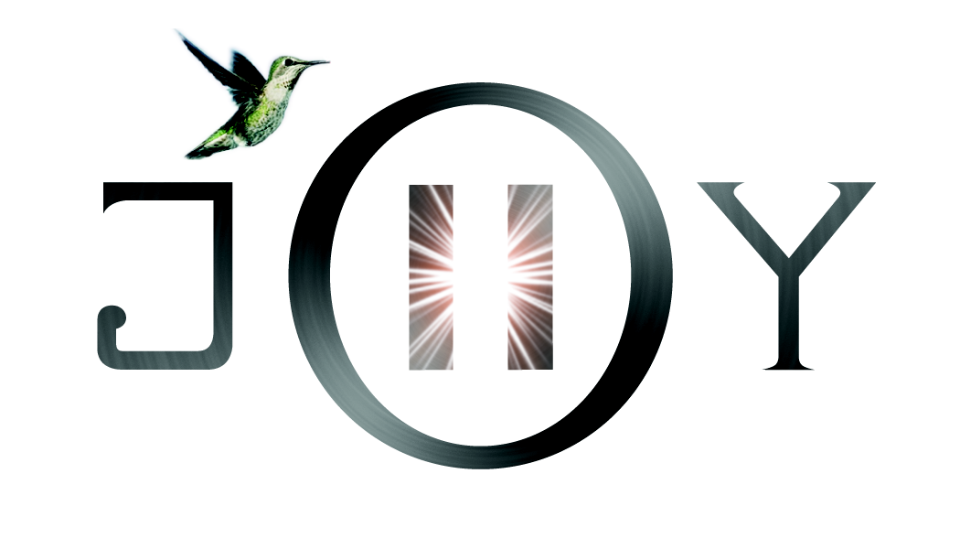
Welcome to Pause inJOY and your first steps to knowing and owning this part of your life’s journey. This application form gives both you and Patti a first energetic connection to ascertain if she is the correct teacher for you and vice versa. Patti believes that choosing your Reiki Master is as much part of the attunement as the attunement itself and the relationship of student/teacher relationship is a sacred one.

Please email an overview of times that best suit your schedule with your application to Patti at email below.

- What experience innately or studied do you currently have with energy, tapping or meditation?

- Do you have a current practice and what does that entail?

- What is it that attracts you to these teachings?
- How do you believe these teachings could help you?
- Do you have a physical, emotional health issue or spiritual currently calling you to this path?

- What are your innate gifts, intuitive knowing or higher wisdom that is guiding you at this time?

- Why Now?

